A

PROJECT REPORT
ON

Online Examination

Submitted To
UNIVERSITY OF PUNE

In Partial Fulfillment of the Requirement Of
MASTER OF COMPUTER APPLICATIONS
(Semester – V)

By
Arvind Singh
Niraj Shirke
Kiran Shette

Under The Guidance Of
Prof. Rajesh Kanzade


SINHGAD INSTITUTE OF BUSINESS ADMINISTRATION AND
COMPUTER APPLICATION, LONAVALA- 410401
2009-2010



Sinhgad Technical Education Society’s
SINHGAD INSTITUTE OF BUSINESS ADMINISTRATION
& COMPUTER APPLICATION (SIBACA),
Kusgaon (Bk.), Lonavala, Pune – 410 401

Certificate
This is to certify that the mini project entitled ‘Online Examination’ being submitted by Mr. Arvind Singh (Roll. No. 58), Mr. Niraj Shirke (Roll. No. 57), Mr. Kiran Shette (Roll. No. 56) in partial fulfillment of the requirement for the award of degree of Master of Computer Applications of the University of Pune, is a record of bona fide work carried out by him under my supervision.

Place : Lonavala
Date : / /2008
Project Guide Project Coordinator Director
Prof. Rajesh Kanzade Prof.Ashok Sabale Prof.Parag Kalkar

Declaration

We, the undersigned hereby declare that the Project report entitled Online Examination is designed, written and submitted by us in partial fulfillment of the requirement for the award of the degree of Master of Computer Applications is our original work. The empirical findings in this report are based on data collected by us through discussion with the project guide.
We understand that, any such copying is liable to us punishment in way the university authorities deem fit.

Place : Lonavala
Date : / /2008 Yours Faithfully,

Mr. Arvind Singh
Mr. Niraj Shirke
Mr. Kiran Shette

Table of Contents
1. Introduction 1
1.1. Project Overview 1
1.2. Purpose 1
1.3. Scope 1
1.4. Definitions, Acronyms 1
2. Functional or Specific Requirements 2
2.1. External Interface Requirements 4
2.1.1. Hardware Interfaces 4
2.1.2. Software Interface 4
2.1.3. Third Party Software Interfaces 4
2.1.4. Communication Protocol 4
2.1.5. Assumption and Dependency 5
2.2. Non-Functional Requirements 5
2.3. Software System Attributes 5
2.3.1. Browser Compatibility 5
2.3.2. Globalization Support 7
2.3.3. Security 8
2.3.4. Reliability 8
2.3.5. Availability 8
2.3.6. Portability 8
2.3.7. Performance 9
2.4. Database Requirements 9
2.5. Technologies 9
2.6. Software 9
2.7. Hardware 9
2.7.1. Server 9
2.7.2. Client 10
3. Analysis and Design 11
3.1. Use Case Diagram 11
3.1.1. Use case Overview 11
3.1.2. Add Faculty Use Case 12
3.1.3. Login Use Case 12
3.1.4. Manage Student Groups Use Case 13
3.1.5. Student Registration Use Case 13
3.1.6. User Profile Edit Use Case 14
3.1.7. Manage Test Use Case 15
3.1.8. Appear for Test Use Case 16
3.1.9. Generate Result Use Case 17
3.2. Activity Diagram 18
3.2.1. Login Activity Diagram 18
3.2.2. Manage Students Activity Diagram 19
3.2.3. Manage Tests Activity Diagram 20
3.2.4. Generate Result Activity Diagram 21
3.2.5. Student Registration Activity Diagram 22
3.2.6. Answer Test Activity Diagram 23
3.3. Sequence Diagrams 24
3.3.1. Sequence Diagram Overview 24
3.3.2. Login Sequence Diagram 25
3.3.3. Manage Student Groups Sequence Diagram 26
3.3.4. Student Registration Sequence Diagram 27
3.3.5. Manage Test Sequence Diagram 28
3.3.6. Appear for Test Sequence Diagram 29
3.4. Class Diagram 30
3.5. Database Design 31
3.5.1. Table: Student 32
3.5.2. Table: Test 32
3.5.3. Table: TestQuestions 32
3.5.4. Table: StudentResponse 33
3.5.5. Table: TestSession 33
3.5.6. Table: Groups 33
3.5.7. Table: Faculty 33
3.5.8. Table: AssignGroupTest 34
4. User Interfaces 35
4.1. Home Page 35
4.2. Registration 36
4.3. Login Interface 37
4.4. Create Questions Interface 37
4.5. Report 38
1. Scope for Enhancement 41
2. Figures and Tables 42
3. References 43

Introduction

Project Overview
This project assesses students by conducting online objective tests. The tests would be highly customizable. This project will enable educational institutes to conduct test and have automated checking of answers based on the response by the candidates.
The project allows faculties to create their own tests. It would enable educational institutes to perform tests, quiz and create feedback forms. It asks faculty to create his/her set of questions. Faculty then creates groups and adds related students into the groups. Further the tests are associated with specific groups so that only associated students can appear for the test. The result of the response would be available to the faculty of the question set. Further the result would also be mailed to the student. This project would be helpful for creating practice tests, say for educational institutes and as a feedback form.

Purpose
- Responses by the candidates will be checked automatically and instantly.
- Online examination will reduce the hectic job of assessing the answers given by the candidates.
- Being an integrated Online Examination System it will reduce paper work.
- Can generate various reports almost instantly when and where required.

Scope
This project would be very useful for educational institutes where regular evaluation of students’ is required. Further it can also be useful for anyone who requires feedback based on objective type responses.

Definitions, Acronyms
The sub-section provides the definitions of all terms, acronyms, and abbreviations used in this document to understand the SRS properly.

Sr. No. | Terms/Acronyms | Description
 | Student | User mostly a student who will appear for the examination
 | Faculty | Another user mostly faculty member, lecturer or examiner who posts set of questions, the available options and correct answers.
 | Administrator | Super user, adds faculty and manages system.

Functional or Specific Requirements
Required software is for conducting on-line `objective’ type examination and providing immediate results. The system should satisfy the following requirements:
- Administrator Aspect
  - Taking backup of the database
  - Editing/Deleting/Creating the database.
  - Adding or expelling faculty
  - Changing the super password.
- Faculty Aspect
  - Logging into the system.
  - Sending invitations to specific student by mail
  - Accepting registrations of candidates
  - Adding the candidate to a group
  - Create/Edit/Delete candidate groups
  - Creating a test
  - Posting questions in the above test
  - Posting multiple options to respective question
  - Marking correct answer within the given options
  - Specifying to allow user defined answer
  - Time limit of the test if any.
  - Whether to randomize the questions
  - Whether to randomize the options displayed
  - To allow the test to be taken in practice mode where the correct answer is shown immediately after the candidate selects an option.
  - Set negative marks for wrong responses
- Student Aspect:
  - Requesting registration
  - Logging into the system.
  - Edit user information.
  - Selecting the test.
  - Selecting whether the test to be taken in practice mode where the correct answer is shown immediately after the candidate selects an option.
  - Appearing for the examination.
  - Printing the result at the end of the examination.
  - Reviewing the given responses.
  - Changing password.
  - Resetting of forgotten password
- Analysis
  - Authenticating users based on username and password
  - Keeping session track of user activity
  - Recording candidates’ responses to every question
  - Checking whether the given response is correct or not
  - Keeping history of test reports of all users
- Mailing
  - The reports are required to be mailed to the candidates on the registered mail address.
  - Temporary password will be mailed to the user incase the user forgets the password.
  - Invitations for the appearance for the new test will be mailed.

External Interface Requirements

Hardware Interfaces
Server side hardware
      - Hardware recommended by all the software needed.
      - Communication hardware to serve client requests
Client side hardware
      - Hardware recommended by respective client’s operating system and web browser.
      - Communication hardware to communicate the server.

Software Interface
Server side software
      - Web server software, Apache Tomcat
      - Server side scripting tools: PHP
      - Database tools: Sedna native XML DBMS.
      - Compatible operating system: Linux
Client side software
      - Web browser supporting JavaScript, refer Browser Compatibility 2.3.1

Third Party Software Interfaces
None

Communication Protocol
Following protocols are required to be permitted on the server side
- HTTP incoming request
- HTTPS incoming request if secure gateway is implemented
Following protocols are required to be permitted on the client side
- HTTP outgoing request
- HTTPS outgoing request if secure gateway is implemented

Assumption and Dependency
- Username are valid email addresses of respective user
- Administrator has the authority to add/delete faculty level accounts.
- Faculty have the authority to approve/expel student
- Faculty have the authority to change student’s group

Non-Functional Requirements
- System should be able handle multiple users
- Database updating should follow transaction processing to avoid data inconsistency.

Software System Attributes

Browser Compatibility
The project being web based required compatibility with at least the popular web browsers. Microsoft Windows XP and above, Linux and Macintosh being the current popular operating system and Microsoft Internet Explorer, Mozilla Firefox, Opera, Safari and Google Chrome being the currently popular web browsers.
Operating System | Win 2000 | WinXP | WinXPSP2 | Win Vista | Win 7 | Mac OS | Linux
Browsers
 | Modern Browsers
IE 8.0 | N/A | SUPP | SUPP | SUPP | SUPP | N/A | N/A
IE 7.0 | N/A | N/A | N/A | N/A |  | N/A
IE 6.0 | N/A | N/A | N/A | N/A |  | N/A
Firefox 3.5 | N/A | SUPP | N/A | N/A |  | N/A
Opera 9.23 | N/A | SUPP | N/A | N/A |  | N/A
Safari 9.27 | N/A | SUPP | N/A | N/A |  | SUPP
 | “Legacy” Old Browsers
IE5.5 | N/A | N/A | N/A | N/A |  | N/A
Netscape | N/A | N/A | N/A | N/A |  | N/A

Globalization Support
The questionnaires and their respective options provided by the faculty may or may not be in English. Hence the questions and their options must be in Unicode format that will accept any Unicode character.

List of Locale
The system will mostly be in US English, although the questions and their options may not be in US English. Hence the questions and their options are to be in Unicode format.
Locale | Date Format | Time Format | Currency Format | Calendar | Character Set
en-US | Use Default | Use Default | Use Default | Use Default | SBCS
Non en-US | dd-MM-yy | HH:mm:ss | Use Default | d-MM-yyyy | MBCS/Unicode

Content to be localized
The following table lists all the possible area in the system and also mentions whether that area should support Globalization.
Interface Type | Needs Localization?
User Interface | Yes*
Emails sent by system, | Yes*
Standard Errors and exceptions logged by system in error log | No
Logos, Images | No
Unit of Measurement ( Ex. Length, Weight, Area, Volume, Paper Size etc) | No
Reports | Yes*
*Limited to questionnaires set by user who posted questions.

Security
- Administrator has the highest authority to edit/delete/create database
- Faculty have the authority to add/expel students
- Students can only view their test records.
- Faculty can view all the test records of every student.
- Critical information like passwords should be transferred in encrypted form
- Passwords should be stored in encrypted form
- Password will not be mailed to the user in case user forgets password, instead either temporary password or a password reset link will be sent.

Reliability
Data validation and verification needs to be done at every stage of activity.
- Validating user input
- Use of locking mechanism while updating database like transaction processing
- Recovering the transaction using rollback.

Availability
The examination system being an online system should be available anytime.
Constraints:
Though the system should be available 24x7 some features may be restricted.
- Quiz creator may allow the specific test to be available only at certain time like scheduled examination.
- The test may be time limited so the candidates appearing will have limited time to answer the test.

Portability
- The web application will be built using PHP which has support to run on any platform provided the required compilers are available.
- For database either XML or MySQL would be used, that too has extensive support over many popular architectures and operating systems.

Constraints:
Portability would be limited to the support provided by the respective application vendor on various architectures and operating environments.

Performance
The system would be used by multiple users at a time and may grow as time passes; the system would need to implement multithreading to achieve acceptable performance. Further a database connection pool may also be required for assigning faster database connection.

Database Requirements
Database fields for questions and respective options must be in Unicode format to handle non English characters

Technologies
This section lists all the technologies for the web based system.
- PHP scripting for server side scripting as it has a very strong support for XML and MySQL.
- XML as database format: The database’ performance requirements are not very high and the ability to have custom fields in case the quiz creator needs to add more than expected answer options. This is limited in any other database management system where we have to first specify the maximum number of fields.
- Apache as web server has a tight integration with PHP and is also available for various popular platforms.

Software
Netbeans or Eclipse for PHP and XML coding.
Apache Tomcat as Web server

Hardware
The recommended hardware specified by the respective software would suffice the needs. The memory and processing power needed would increase as the number of users increase. The estimated hardware requirements are as specified.

Server
The minimum hardware as recommended by all of the software required on server side say web server, operating system and development software
- Processing speed of 1.6 GHz
- 1 GB of RAM
- Network interface

Client
The minimum hardware as recommended by all of the software required on client side say web browser, operating system
- Minimum hardware depending on the operating system used
- True color visual display unit
- User peripherals for better interaction

Analysis and Design

Use Case Diagram

Use case Overview
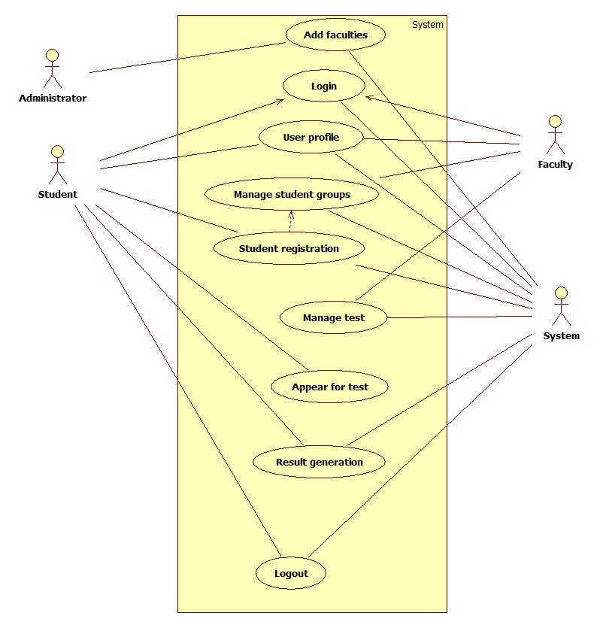

Add Faculty Use Case
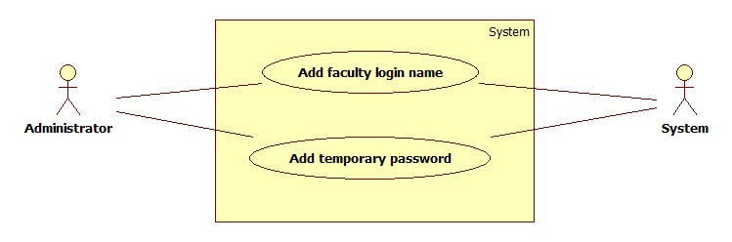

Login Use Case
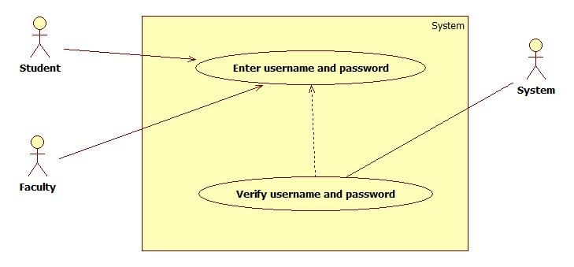

Manage Student Groups Use Case
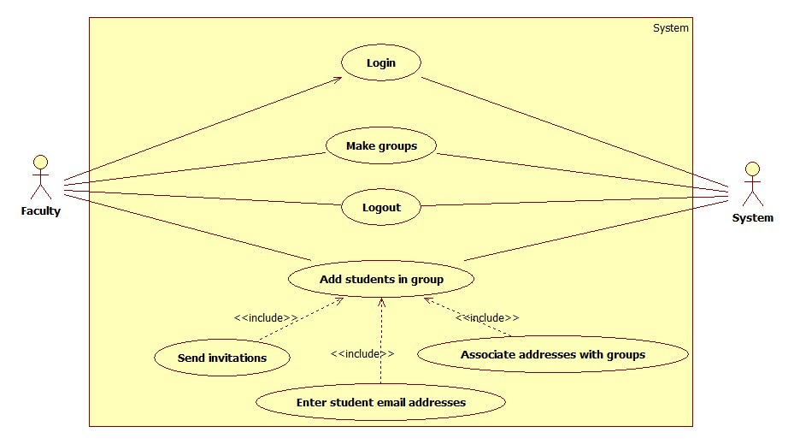

Student Registration Use Case
`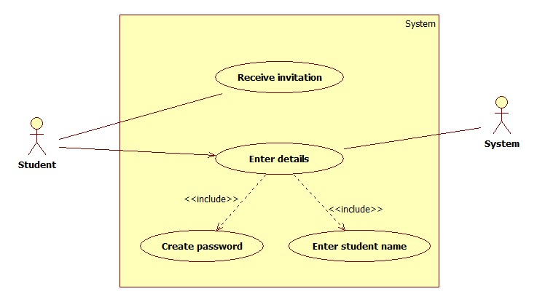

User Profile Edit Use Case
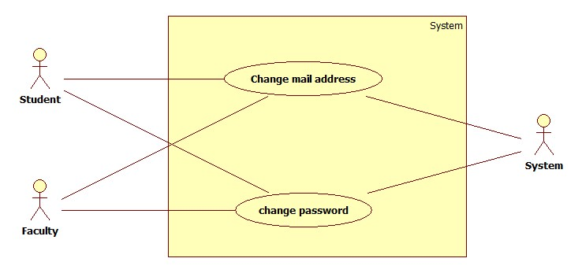

Manage Test Use Case
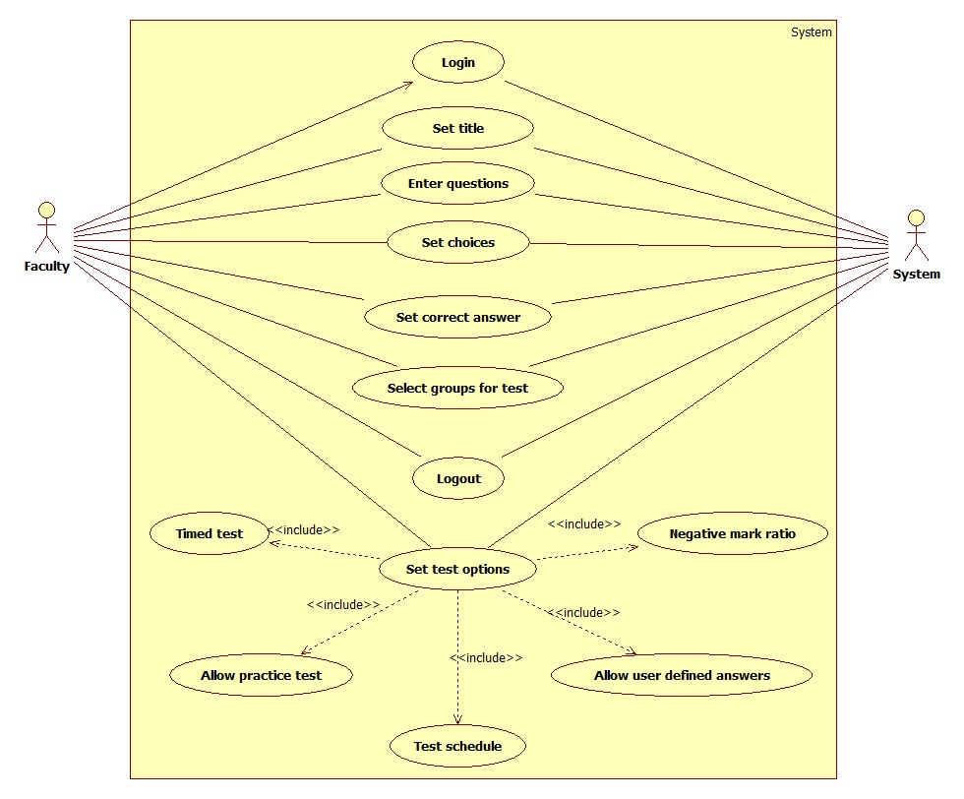

Appear for Test Use Case
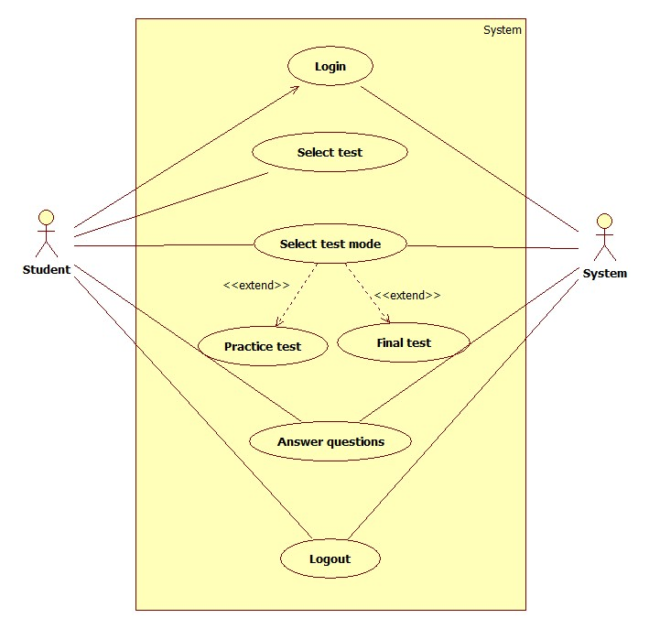

Generate Result Use Case
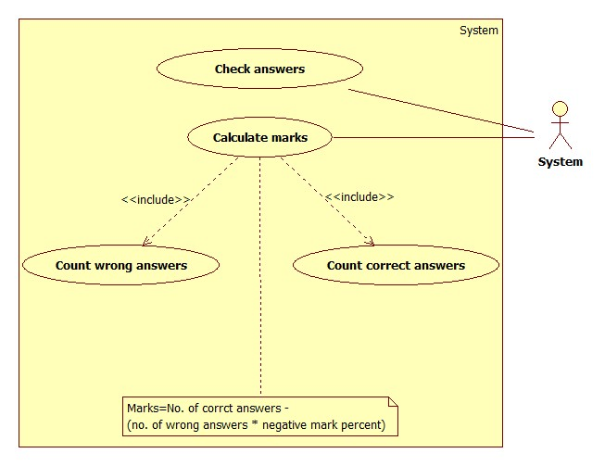

Activity Diagram

Login Activity Diagram
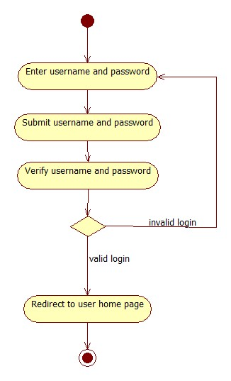

Manage Students Activity Diagram
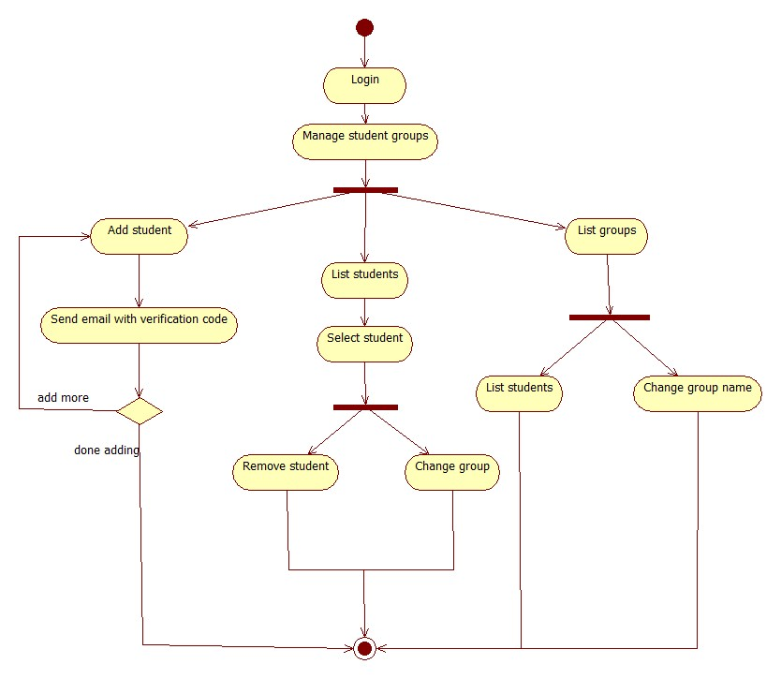

Manage Tests Activity Diagram
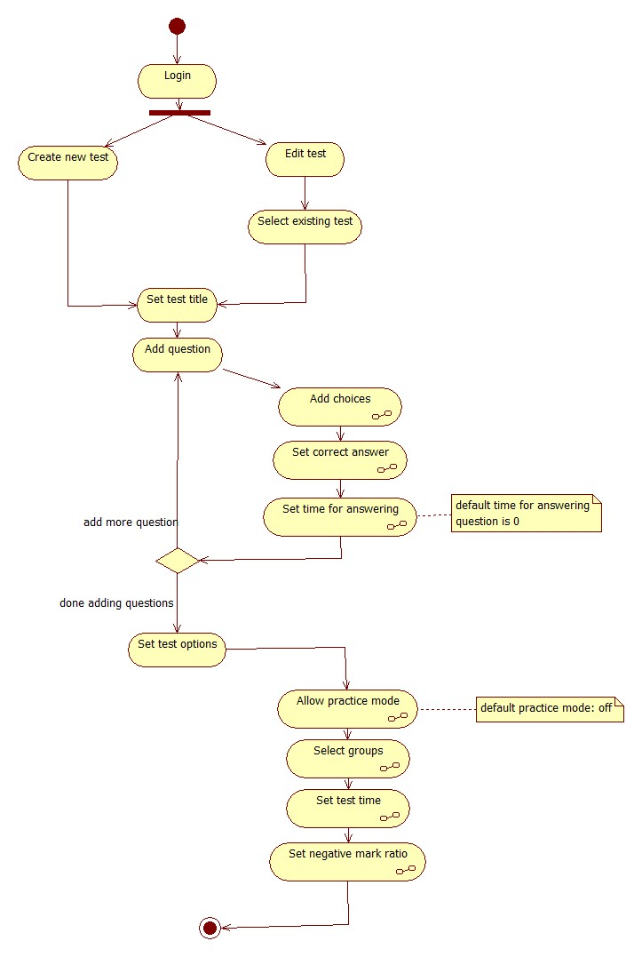

Generate Result Activity Diagram
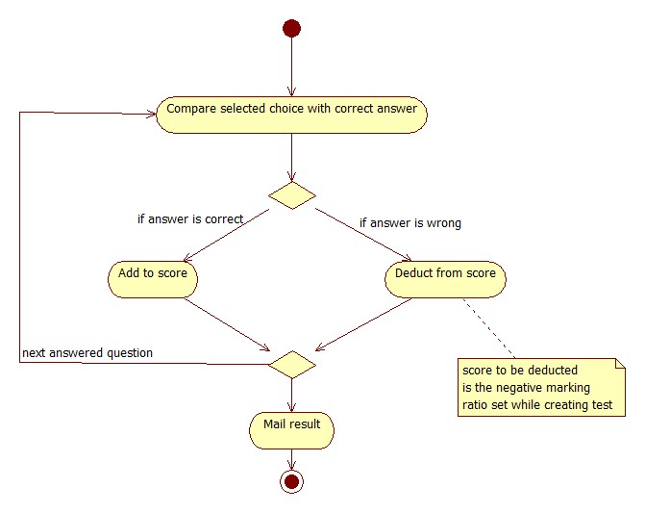

Student Registration Activity Diagram
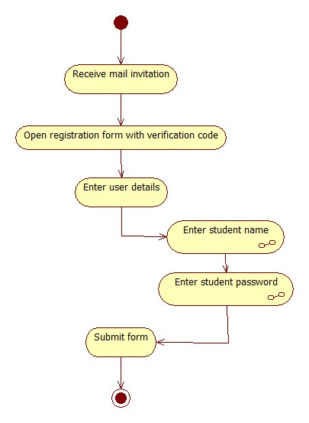

Answer Test Activity Diagram

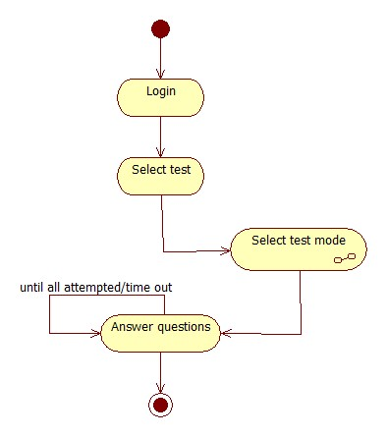

Sequence Diagrams

Sequence Diagram Overview
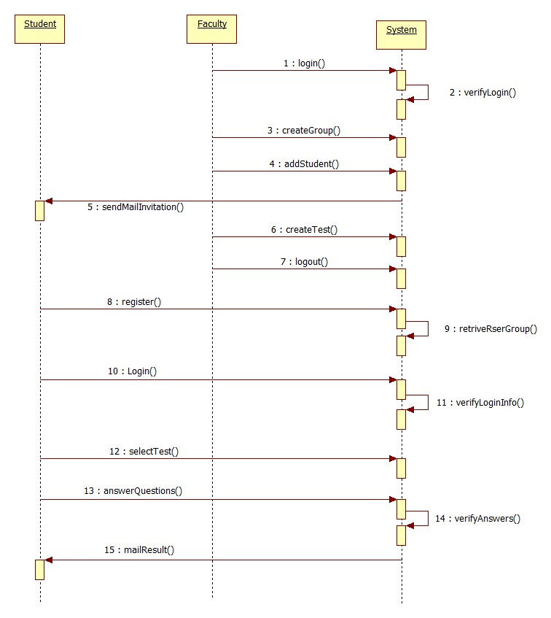

Login Sequence Diagram
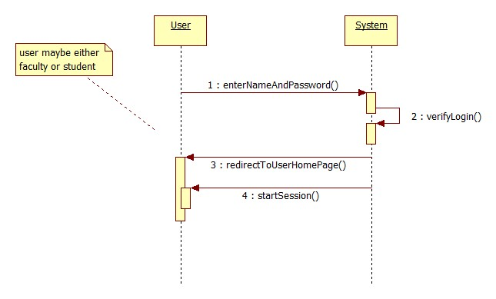

Manage Student Groups Sequence Diagram
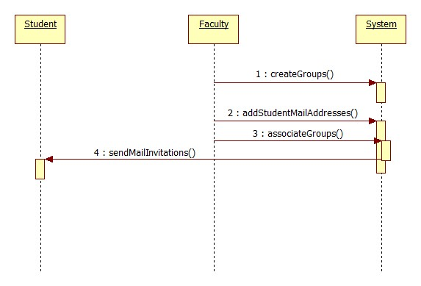

Student Registration Sequence Diagram
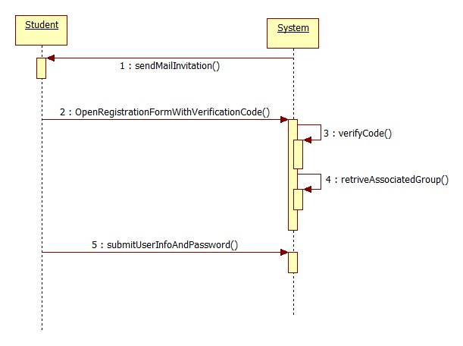

Manage Test Sequence Diagram
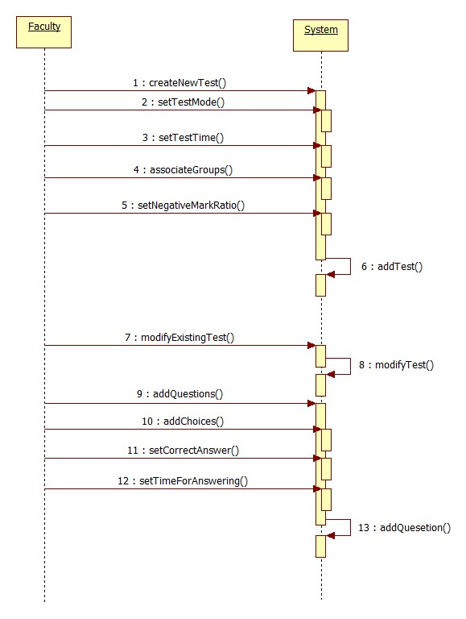

Appear for Test Sequence Diagram
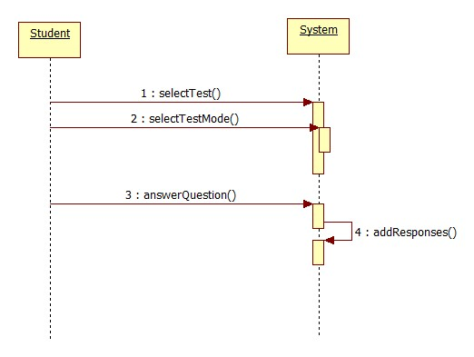

Class Diagram
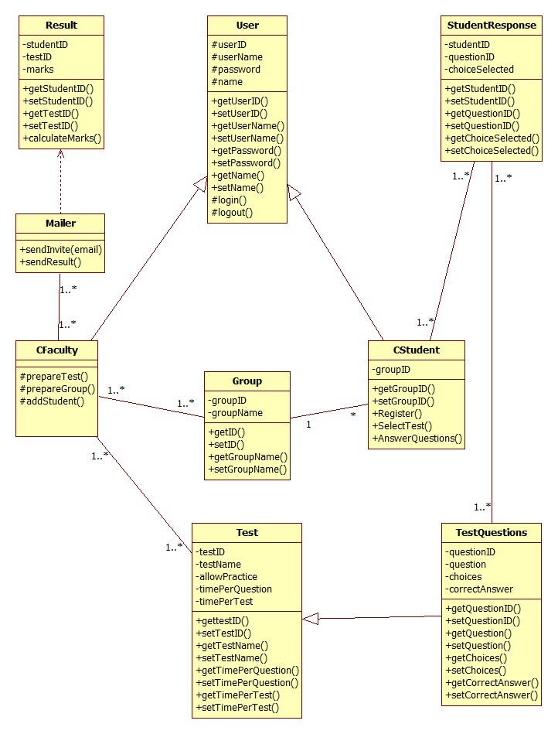

Database Design
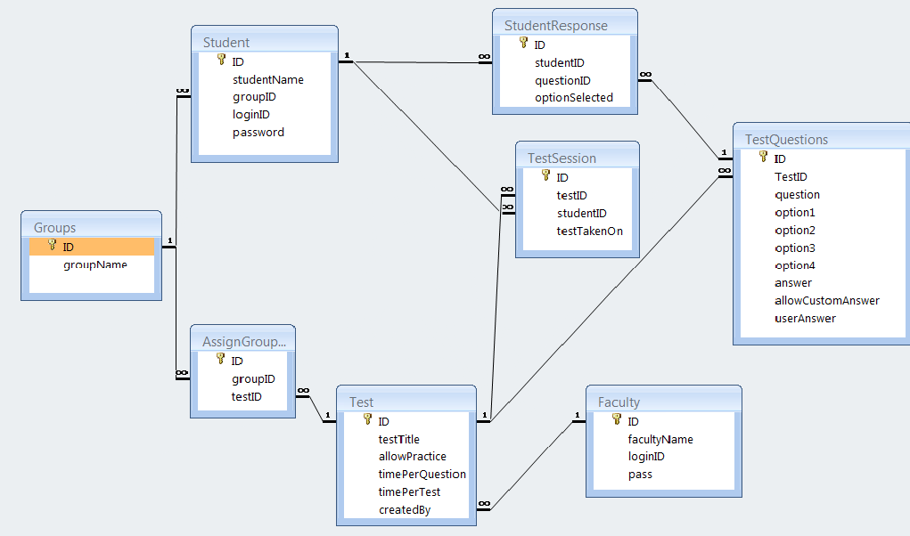

Table: Student
Field Name | Data Type | Constraints/Description
ID | Unsigned Integer | Primary Key, AutoIncrement
studentName | Varchar2
groupID | Unsigned Integer | Foreign:Groups.ID
loginID | Varchar2
password | Varchar2

Table: Test
Field Name | Data Type | Description
ID | Unsigned Integer | Primary Key, AutoIncrement
testTitle | Varchar2
allowPractice | Yes/No
timePerQuestion | Unsigned Integer | in seconds, infinite if zero
timePerTest | Unsigned Integer | in minutes, infinite if zero
createdBy | Unsigned Integer | Foreign:Faculty.ID

Table: TestQuestions
Field Name | Data Type | Description
ID | Unsigned Integer | Primary Key, AutoIncrement
TestID | Number | Foreign:Test.ID
question | Varchar2
option1 | Varchar2 | atleast two choices are required, hence this field is required
option2 | Varchar2 | atleast two choices are required, hence this field is required
option3 | Varchar2
option4 | Varchar2
answer | Unsigned Integer
allowCustomAnswer | Boolean
userAnswer | Varchar2

Table: StudentResponse
Field Name | Data Type | Description
ID | Unsigned Integer | Primary Key, AutoIncrement
studentID | Unsigned Integer | Foreign:Student.ID
questionID | Unsigned Integer | Foreign:TestQuestions.ID
optionSelected | Unsigned Integer | if student does not answer, entry will not be made in db
customAnswer | Varchar2 | only if optionSelected field is 0

Table: TestSession
Field Name | Data Type | Description
ID | Unsigned Integer | Primary Key, AutoIncrement
testID | Unsigned Integer | Foreign:Test.ID
studentID | Unsigned Integer | Foreign:Student.ID
testTakenOn | Date/Time | field required

Table: Groups
Field Name | Data Type | Description
ID | Unsigned Integer | Primary Key, AutoIncrement
groupName | Unsigned Integer

Table: Faculty
Field Name | Data Type | Description
ID | Unsigned Integer | Primary Key, AutoIncrement
facultyName | Varchar2
loginID | Varchar2
pass | Varchar2

Table: AssignGroupTest
Field Name | Data Type | Description
ID | Unsigned Integer | Primary Key, AutoIncrement
groupID | Unsigned Integer | Foreign:Groups.ID
testID | Unsigned Integer | Foreign:Test.ID

User Interfaces
The interfaces of this system are as below

Home Page
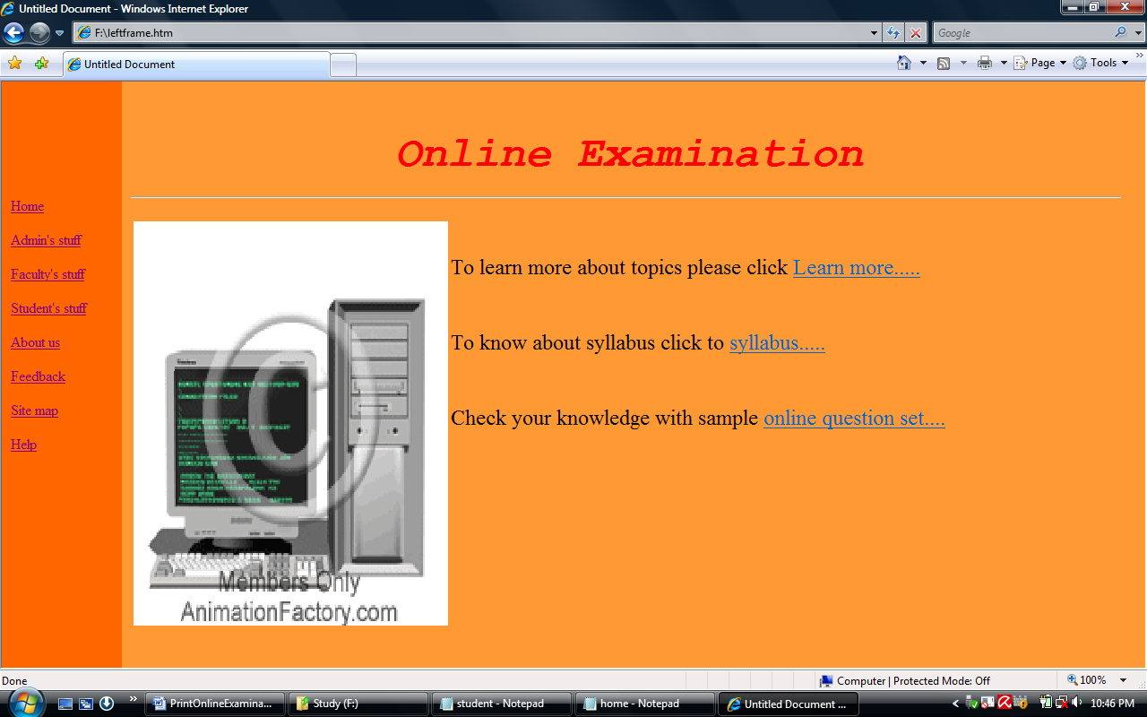

Registration
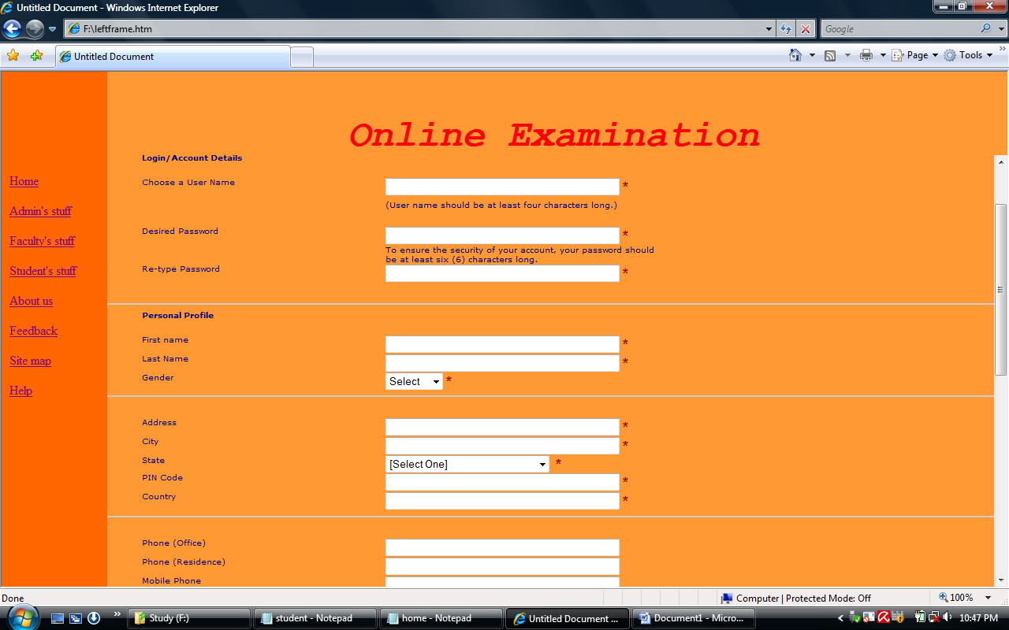

Login Interface
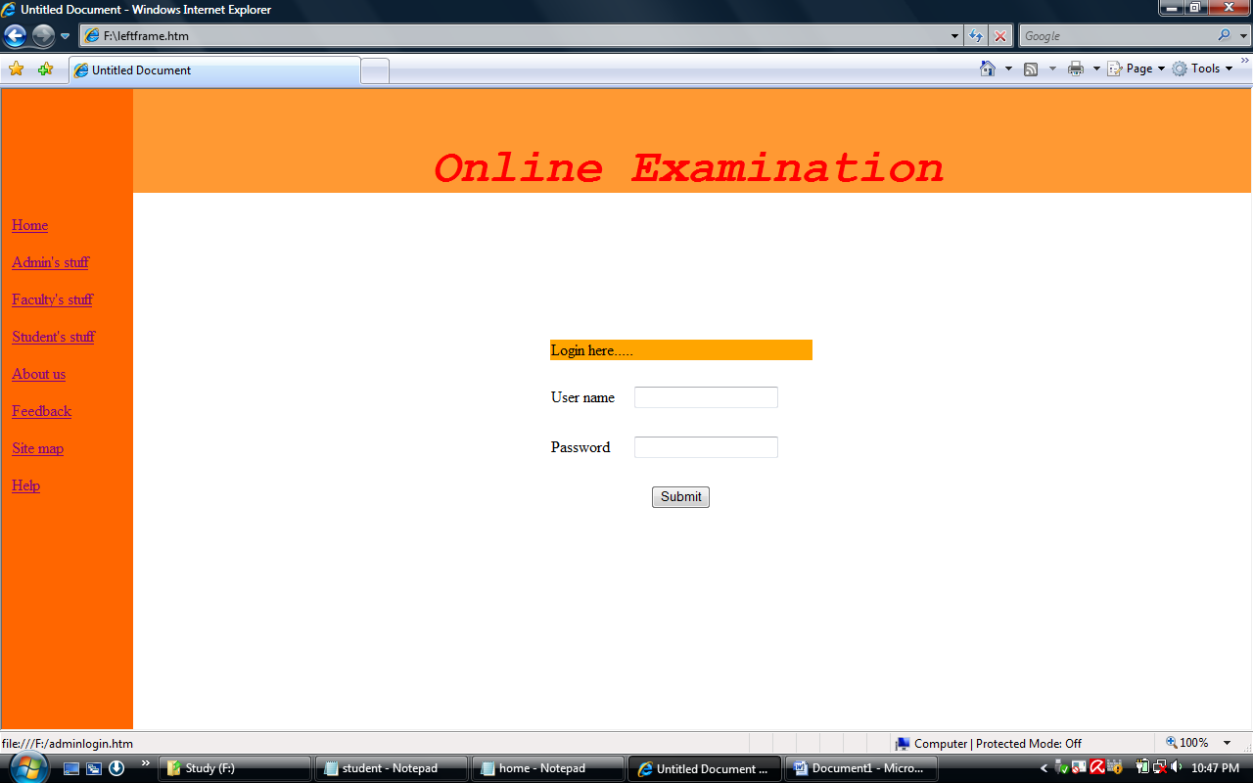

Create Questions Interface
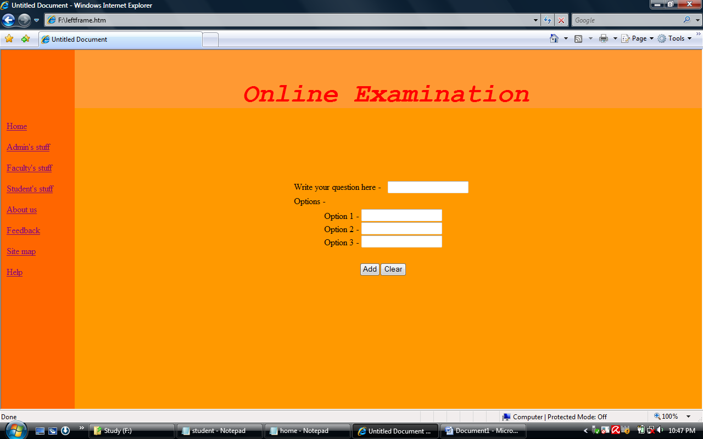

Report
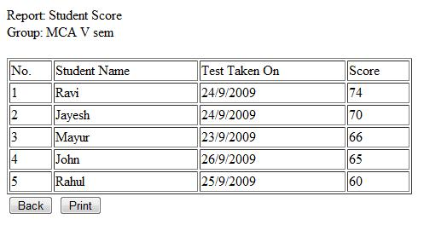

1] Test case For Log In:

Project : - Online Examination System.
Objective : - To check whether user name & Password valid or invalid.
Prepared By: - Team-P
Page : - Login Screen.
Test Data : - User=”admin” and Password =”123.4”.

Sr No. | Steps | Data | Excepted Data | Actual result | Status
1 | Enter user name, password and press submit button |  | Should navigate to admin’s page |  | Pass
2 | Enter User name and press submit button. |  | Should Display message box ‘please fill all the fields’ |  | Pass
3 | Enter password and press submit button |  | Should Display message box ‘please fill all the fields’ |  | Pass
4 | Enter blank user name and blank password and press submit button. |  | Should display a message box ‘please fill all the fields’ |  | Pass
5 | Enter wrong user and password. |  | Should display a message box ‘Invalid ID or Password’ |  | Pass

2] Test case For Navigation:
Project : - Online Examination System.
Objective : - To check whether different hyperlinks are working properly or not.
Prepared By: - Team-P
Page : - home page (default page).

Sr No. | Steps | Data | Excepted Data | Actual Result | Status
1 | Click on Home page hyperlink menu |  | Should display home page |  | Pass
2 | Click on new questionnaires hyperlink menu |  | Should display questionnaires details page |  | Pass
3 | Click on quiz hyperlink menu |  | Should display quiz details page |  | Pass
4 | Click on show result hyperlink menu |  | Should display result details page |  | Pass
5 | Click on login hyperlink menu |  | Should display respective login page |  | Pass
6 | Click on queries hyperlink menu |  | Should display queries details page |  | Pass
7 | Click on feedback hyperlink menu |  | Should display feedback form page |  | pass

Scope for Enhancement
Present system carries certain drawbacks and limitations as listed below
- Current system provides only multiple choices but single correct answer selection. Faculty may wish to provide multiple choices multiple selection responses.
- Incase questions and/or answers need to be in graphics, current system has no provision.
- Unregistered users cannot answer test, they must belong to some group. This is a drawback incase the faculty wants anyone even anonymous users to answer the test.
- Top score could be displayed on the home page; but this could be easily implemented while programming the home page.
- Security logs though not implemented in this system would be well available through the respective database management system and web server software.

Figures and Tables
- 3.1.1. Use case Overview 13
- 3.1.2. Add Faculty Use Case 14
- 3.1.3. Login Use Case 14
- 3.1.4. Manage Student Groups Use Case 15
- 3.1.5. Student Registration Use Case 15
- 3.1.6. User Profile Edit Use Case 16
- 3.1.7. Manage Test Use Case 17
- 3.1.8. Appear for Test Use Case 18
- 3.1.9. Generate Result Use Case 19
- 3.2.1. Login Activity Diagram 20
- 3.2.2. Manage Students Activity Diagram 21
- 3.2.3. Manage Tests Activity Diagram 22
- 3.2.4. Generate Result Activity Diagram 23
- 3.2.5. Student Registration Activity Diagram 24
- 3.2.6. Answer Test Activity Diagram 25
- 3.3.1. Sequence Diagram Overview 26
- 3.3.2. Login Sequence Diagram 27
- 3.3.3. Manage Student Groups Sequence Diagram 28
- 3.3.4. Student Registration Sequence Diagram 29
- 3.3.5. Manage Test Sequence Diagram 30
- 3.3.6. Appear for Test Sequence Diagram 31
- 3.4 Class Diagram 32
- 3.5. Database Design 33
- 3.5.1. Table: Student 34
- 3.5.2. Table: Test 34
- 3.5.3. Table: TestQuestions 34
- 3.5.4. Table: StudentResponse 35
- 3.5.5. Table: TestSession 35
- 3.5.6. Table: Groups 35
- 3.5.7. Table: Faculty 35
- 3.5.8. Table: AssignGroupTest 36
- 4.1. Login Interface 37
- 4.2. Create Group Interface 37
- 4.3. Assign Test Interface 38
- 4.4. Create Questions Interface 39
- 4.5. Register Students Interface 40

References
  - Sedna native XML http://modis.ispras.ru
  - Apache Tomcat http://tomcat.apache.org
  - MySQL http://www.mysql.com
  - UML official website http://www.uml.org/
  - StarUML - The Open Source UML/MDA Platform http://staruml.sourceforge.net/

